Indianapolis  Kokomo  Avon  Fishers  Terre Haute
1.800.888.HAND

GOLF EXERCISES – STRETCHING

Introduction
Golf is a game which does not replicate the normal movement patterns performed in day to day activities. The asymmetrical movement pattern and repetitions of the golf swing can be damaging to virtually all the joints and soft tissue structures of the body. Basically, none of the movement patterns in the golf swing “are good for your health”. Thus, having excellent flexibility is important for preventing golf-related injuries.

Stretching exercises play an instrumental role in maximizing flexibility, which is essential for achieving a quality golf swing and for preventing injuries to the body. Some of the benefits of stretching include:
- Improve flexibility
- Improve muscle performance
- Promote circulation
- Reduce the chance of muscle, tendon and ligament injuries
- Reduce muscle stiffness and soreness
- Help protect the joints
- Improve the golf swing

The following exercises serve as key stretching exercises for the golfer. The exercises focus on those muscles essential for the back swing, down swing and follow through. Certainly, more exercises can be added, but these exercises, in and of themselves, serve as especially valuable for the golfer.

You will find it interesting that there are a limited number of upper extremity exercises in this handout. Please know the vast majority of the movement pattern and strength in the golf swing comes from the trunk, hips, gluts and legs. Thus, there is greater focus on stretching lower extremity and trunk muscles as opposed to the upper extremity.

Hopefully, it is helpful and exciting to know that many exercises for the legs and trunk can be performed safely in the early stages of recovery from upper extremity medical conditions, injuries and surgeries. By beginning some of these exercises early on, this will facilitate your return to golf.

This series of exercises avoid exercises that generate compressive loads to the wrist, elbow, and shoulder, which serve as common sites of injury for the golfer. In addition, the exercises limit stress on the low back, another common problem area for golfers.

Home Therapy Program
The following therapy program has been custom-designed, based on your initial evaluation. The primary goals are to facilitate your recovery, your return to golf and your golf performance.

The exercises are meant to be performed easily at home, with limited equipment and in a short period of time.

GOLF EXERCISES – STRETCHING (continued)
General Guidelines

- Always warm up for 3-5 minutes before performing the stretching exercises. [Examples: brisk walk, treadmill, stationary bike]
- Complete ________ repetitions of the circled exercises.
- Perform each exercise slowly, holding the end-range for _______ seconds.
- You will begin with active dynamic stretches and then transition to a series of end-range stretches.
- Please know “more is not better” with your exercises. Follow the guidance of your therapist or doctor.
- Should any of the exercises generate pain, discontinue the exercise and consult your therapist.

Standing Exercises – Dynamic Stretches

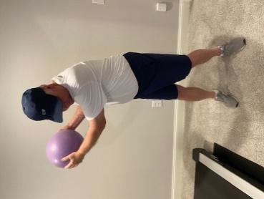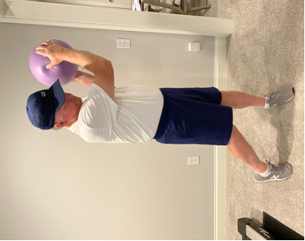  - Holding an object ± 18” in diameter, simulate a golf swing by rotating your trunk & shoulders to the right & then to the left. Repeat by reversing the swing, left to right. |  | 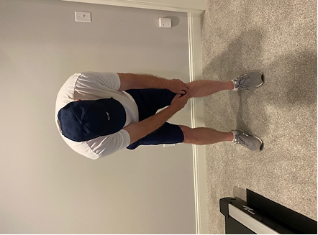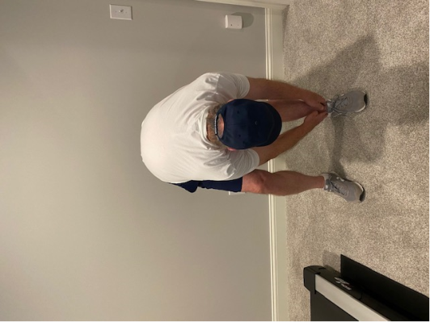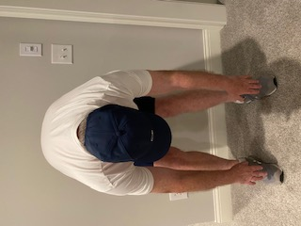  (A)  (A)  (B)  - (A) Bend at your waist & turn to touch your left knee, then your left ankle. Repeat for the right. (B) Bend at the waist with both arms and reach for the ground.

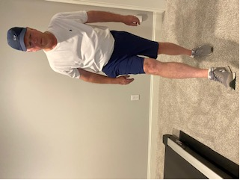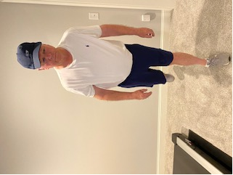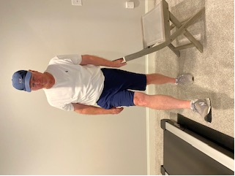  - While standing, swing your leg forward and back, 10-20 repetitions. Repeat with other leg. Feel free to hold onto a stationary object for balance (tabletop or chair). |  | 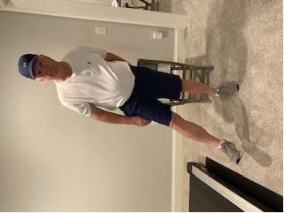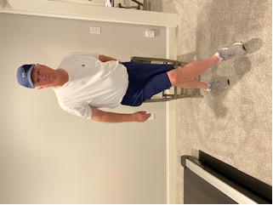
 |  | - While standing, swing your leg across the other leg 10-20 repetitions. After this, switch and swing the other leg. Feel free to hold onto a tabletop or chair for balance.

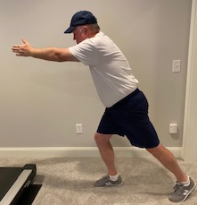  - With the hips and knees slightly bent & your arms forward, stretch your legs apart to walk forward 5 steps and backwards 5 steps.  GOLF EXERCISES – STRETCHING (continued) |  | 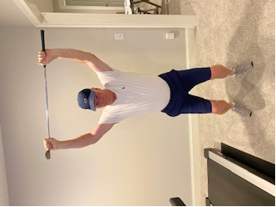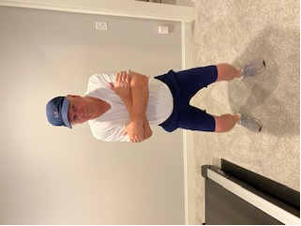  (B)  (A)  - (A) Perform an overhead squat, while holding a golf club or dowel rod. (B) Perform the squat with the arms crossing over the chest. [Note: You may do this exercise as a wall squat.]
Standing Exercises – Static Stretches

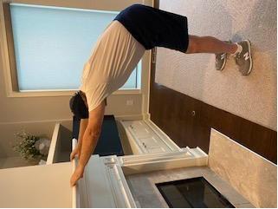  - Hold onto a ledge and begin bending your hips and then your knees closer to the ground. This will stretch your lats. | 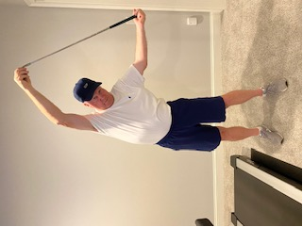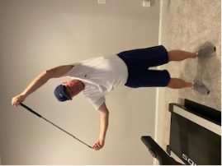  - While standing, lean to one side, pushing your arm with a dowel rod. Repeat opposite side. This is a nice stretch for your obliques. | 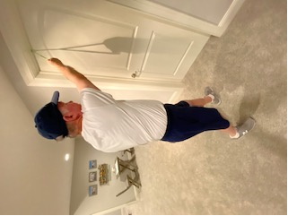  - While holding a strap or tubing with the right hand palm up, step back from & to the right of the door to place a quality stretch on the side of the trunk for the lats. Repeat for the left side.

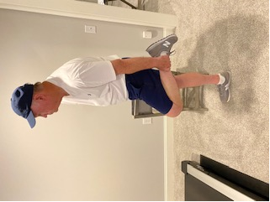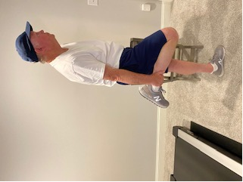  - (A) While standing, hold one leg with the knee bent behind the body. (B) Repeat with the opposite leg. Maintain an upright posture, with the hip straight (not bent forward). This is a great stretch for your quads. |  | 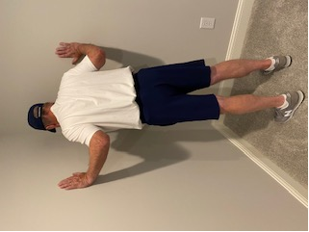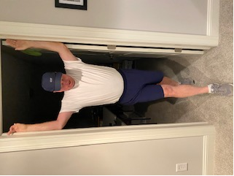  (B)  - (A) Perform a corner wall stretch, where you lean into the wall. (B) Another exercise is to place both arms in a door frame and then walk into the door space to stretch the chest muscles.

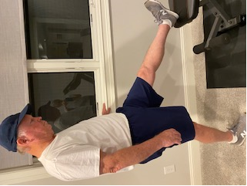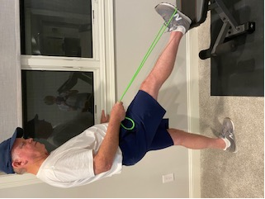  - While standing, place your leg on an elevated surface (e.g. step stool, workout bench). With your knee straight, stretch your ankle toward you with a towel or tubing. Stretch both legs. This will stretch your hamstrings and calf muscles. |  | 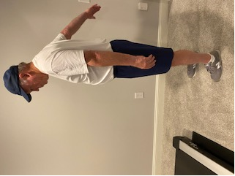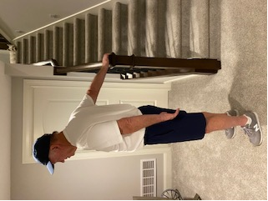  (B)  (A)  - (A) While standing, reach straight behind your back as high as you can. (B) Follow this with holding onto a stationary object to allow your biceps to stretch further. Repeat for both arms.

GOLF EXERCISES – STRETCHING (continued)
Sitting Exercises – Static Stretches

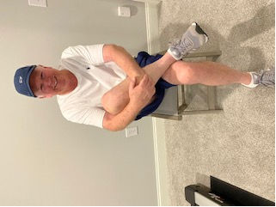  - While sitting, with one leg bent over the other, stretch the bent leg toward the middle of your stomach. Repeat opposite leg. | 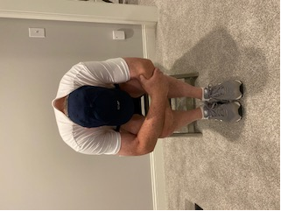  - While sitting in a chair, bend at your waist and hold your legs. This is a good stretch for your low back and gluts. | 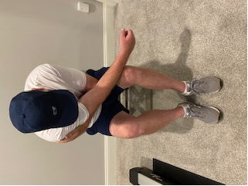  - While sitting, and leaning forward, use one arm to draw the other arm and trunk forward and toward the opposite side of your body to stretch the rhomboids.

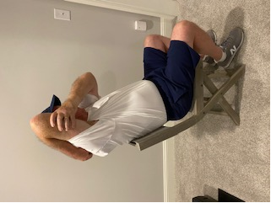 | 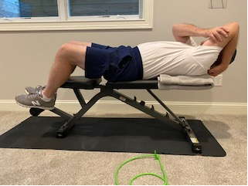 | 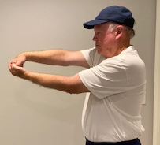 | 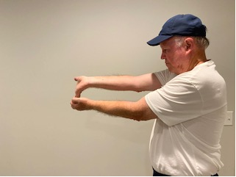
- Bend your elbow & push your arm overhead with your hand. Repeat, opposite arm. Great triceps stretch. | - With the shoulder blade supported, perform the same stretch as #17. Repeat, opposite arm. Great triceps stretch. | - With your elbow straight & forearm palm down, stretch the wrist down to limit the risk of tennis elbow. | - With your elbow straight & forearm palm up, stretch the wrist back to limit the risk of golfer’s elbow.
Floor Exercises – Static Stretches
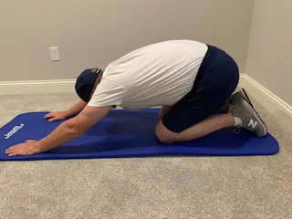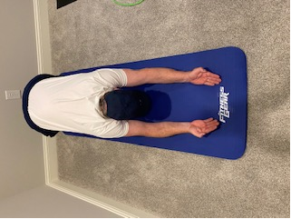  B  A  - (A) While sitting on bent knees, stretch your arms forward. Maintain a good posture. (B) Perform the same stretch with the palms up. This is a good stretch for the lats, back and gluts. |  | 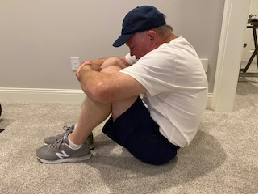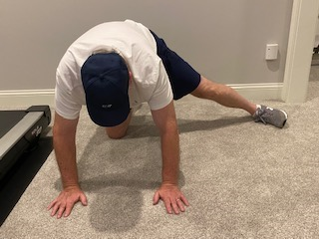  (A)  (B)  - (A) Sit with both knees bent, lean forward holding both legs against the chest to stretch back muscles. (B) Lean down on one knee, widely stretch the opposite leg. Repeat, opposite leg. You should feel a good stretch on the inside of your leg. This includes the hip adductors.

GOLF EXERCISES – STRETCHING (continued)
Floor & Standing Exercises – Static Stretches
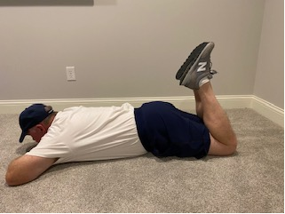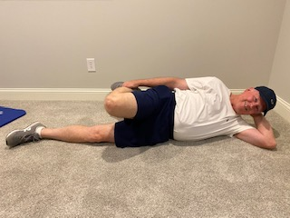  (B)  (A)  - (A) While lying on your stomach, bend both knees. Hold the legs in the bent position. This will stretch the quads. If your heels cannot touch your body, help stretch with your hand. (B) An alternative would be side-lying, where you hold your leg and bend it. Repeat opposite leg. This is a good stretch for the quads. Try to avoid the hip bending forward. |  | 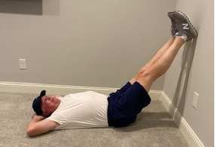  - While lying on your back, place your legs on the wall. While keeping your legs straight, attempt to get a bit closer to the wall with your body. The goal is to be able to bend at your waist close to a 90° angle. This is a great stretch for your hamstrings.

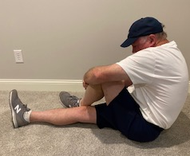  - While sitting, cross one leg over a straight leg. Bend the leg at the hip & knee toward the stomach & across the straight leg to stretch the hip abductors & glut medius. | 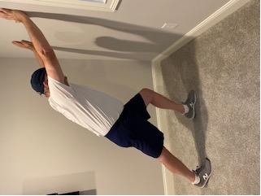  - With hands on wall, step back and lean back on right leg to stretch the calf muscles & achilles. Keep foot on floor. Repeat, opposite leg. | 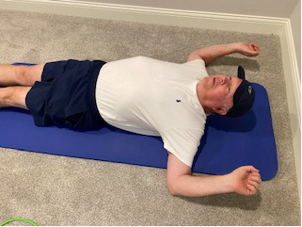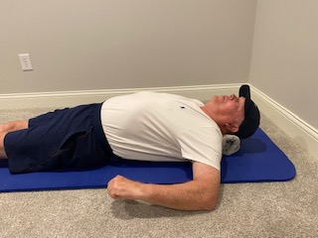  - (A)While lying on your back (with a hand towel down the length of your back), bring your arms out to your sides. Bend your elbows 90°. Allow your arms to stretch backwards. (B) Repeat this with the arms going forwards. Great stretches for the rotator cuff.

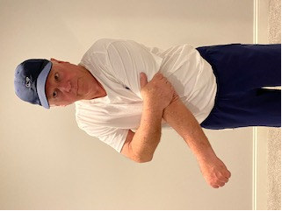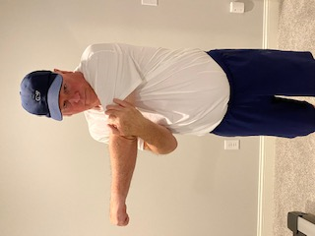  - (A) While standing, use one hand to bring the opposite arm across the body in a diagonal pattern. (B) [Note: Horizontal adduction (directly across the body) can aggravate A-C joint arthritis & impingement. It is recommended to avoid this specific exercise with golfers. |  | 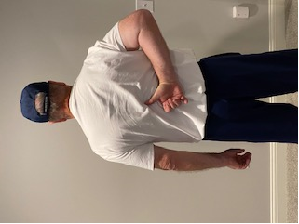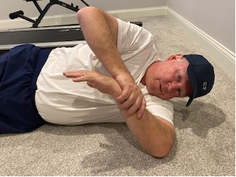  - While standing, bring one arm behind the back and attempt to raise the hand up the middle of the back. Maintain an upright posture.  - While side-lying on the floor, stretch the shoulder by bringing it closer to the floor.

GOLF EXERCISES – STRETCHING (continued)
Additional Exercises:
- ___________________________________________________________________________________________
- ___________________________________________________________________________________________

- ___________________________________________________________________________________________

- ___________________________________________________________________________________________
Home Program

- Perform the circled exercises. Additional exercises will be added as indicated.
- Perform _________ repetitions of each exercise.
- Hold the end range of the exercise for _______ seconds.
- Perform the exercises ________ times a day week
- Discontinue any exercise that increases your level of pain. Some soreness is expected, but that should go away within an hour or two following exercise.
- If you were advised to wear a wrist strap or brace while performing the exercises, please be sure wear the added support.
- Stay committed to your exercise schedule!
- If you have begun the transition back into practicing and playing golf, feel free to perform the initial dynamic stretching exercises before golf and conclude with the remaining stretches once home from golf.

Additional Suggestions
- For quality health, stay well hydrated and eat healthy! Proper nutrition will help keep your soft tissue structures (muscles, ligaments, tendons) and joints strong and flexible.
- Swimming is a great exercise for the total body. It is pretty ideal for the golfer.
- Ask fellow golfers to exercise with you.
- If you have not been able to play golf due to a medical condition, injury or surgery, just go out with your friends and walk/ride along. You will be happier and it will keep you connected to your sport!
- Practicing your putting can greatly benefit your golf game. If you can putt, but not swing your clubs yet, make this a priority to help improve your game!

Golf Handouts
- We have a number of handouts available on golf, including our golf evaluation, a series of stretching and endurance/strengthening exercises, patient education (injury prevention), and a practice and playing schedule for a gradual return to golf. The forms are available at www.indianahandtoshoulder.com. Click on the Therapy section to print.

